Resources:

<https://reactjs.org/docs/components-and-props.html>

components accepts arbitrary input call “props”, and return to the DOM based on the props get passed in.

We have two ways to create a component in react

1. Function components

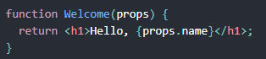

1. Class components

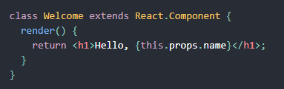

When react sees users using a user-defined component, it passes the children and attribute of this component as one single object, call “props”

In the following example, props could be described as

Props{

Name: “sara”

}

So in the Welcome function component, it can get access to {props.name}

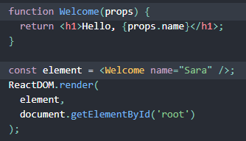

When passing in a props component, we can use

<Avatar user = “Jay”>

And when accessing the user attribute in Avatar component, we do it by

Const username = props.user

Note: in react please always name the component starting with Capital letter, because react treats components starting with lower case as HTML tags.

To learn more about why:

<https://reactjs.org/docs/jsx-in-depth.html#user-defined-components-must-be-capitalized>

**Pure function and impure function**

Pure Fcuntion:

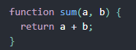

Pure because it is not trying to modify its input

Impure Function:

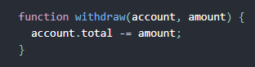

All function must act as Pure Function when using props, hence, props are immutable.